Paul Collado
CSC-208-60
Nov 03, 2010

ColladoCh06Page276
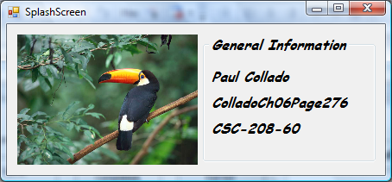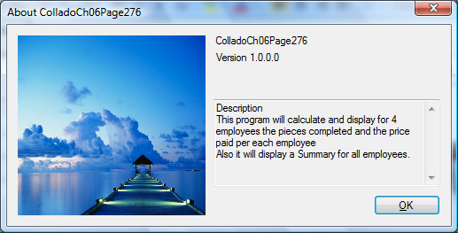

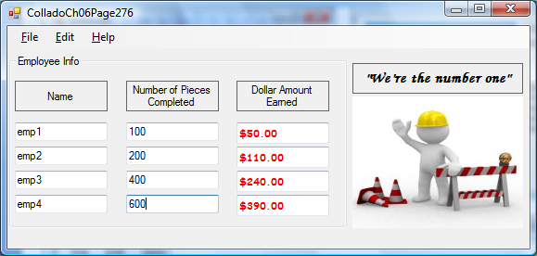

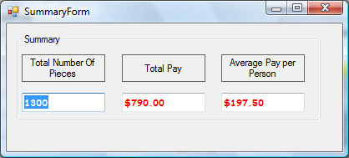

Public Class FrmColladoCh06Page276
Dim DollarEarned1 As Decimal
Dim DollarEarned2 As Decimal
Dim DollarEarned3 As Decimal
Dim DollarEarned4 As Decimal

Dim PriceperPiece1 As Decimal
Dim PriceperPiece2 As Decimal
Dim PriceperPiece3 As Decimal
Dim PriceperPiece4 As Decimal

Dim pieces1 As Integer
Dim pieces2 As Integer
Dim pieces3 As Integer
Dim pieces4 As Integer

Private Sub CalculatePayToolStripMenuItem_Click(ByVal sender As System.Object, ByVal e As System.EventArgs) Handles CalculatePayToolStripMenuItem.Click

If (Me.TxtEmployee1.Text = "" Or Me.TxtEmployee2.Text = "" _
Or Me.TxtEmployee3.Text = "" Or Me.TxtEmployee4.Text = "" _
Or Me.TxtNumOfPieces1.Text = "" Or Me.TxtNumOfPieces2.Text = "" _
Or Me.TxtNumOfPieces3.Text = "" Or Me.TxtNumOfPieces4.Text = "") Then
Try
Me.TxtEmployee1.Text = "" Or Me.TxtEmployee2.Text = "" _
Or Me.TxtEmployee3.Text = "" Or Me.TxtEmployee4.Text = "" _
Or Me.TxtNumOfPieces1.Text = "" Or Me.TxtNumOfPieces2.Text = "" _
Or Me.TxtNumOfPieces3.Text = "" Or Me.TxtNumOfPieces4.Text = ""

Catch ex As Exception
MessageBox.Show("Please fill all Names and all Number Of Pieces Completed", "DATA ENTRY ERROR!")
End Try
Else
pieces1 = Val(Me.TxtNumOfPieces1.Text)
pieces2 = Val(Me.TxtNumOfPieces2.Text)
pieces3 = Val(Me.TxtNumOfPieces3.Text)
pieces4 = Val(Me.TxtNumOfPieces4.Text)

PriceperPiece1 = FindPayRate(pieces1)
PriceperPiece2 = FindPayRate(pieces2)
PriceperPiece3 = FindPayRate(pieces3)
PriceperPiece4 = FindPayRate(pieces4)

DollarEarned1 = pieces1 * PriceperPiece1
DollarEarned2 = pieces2 * PriceperPiece2
DollarEarned3 = pieces3 * PriceperPiece3
DollarEarned4 = pieces4 * PriceperPiece4

Me.TxtDollarEarned1.Text = FormatCurrency(DollarEarned1)
Me.TxtDollarEarned2.Text = FormatCurrency(DollarEarned2)
Me.TxtDollarEarned3.Text = FormatCurrency(DollarEarned3)
Me.TxtDollarEarned4.Text = FormatCurrency(DollarEarned4)

SummaryToolStripMenuItem.Enabled = True
End If

End Sub

Private Function FindPayRate(ByVal QtyOfPieces As Integer) As Decimal
If (QtyOfPieces < 200) Then
FindPayRate = 0.5
ElseIf (QtyOfPieces > 199 And QtyOfPieces < 400) Then
FindPayRate = 0.55
ElseIf (QtyOfPieces > 399 And QtyOfPieces < 600) Then
FindPayRate = 0.6
ElseIf (QtyOfPieces > 599) Then
FindPayRate = 0.65
End If
End Function

Private Sub SummaryToolStripMenuItem_Click(ByVal sender As System.Object, ByVal e As System.EventArgs) Handles SummaryToolStripMenuItem.Click
Dim TotalPieces As Integer
Dim TotalEarned As Decimal
Dim Average As Decimal

TotalPieces = pieces1 + pieces2 + pieces3 + pieces4
FrmSummaryForm.TxtTotalNumOfPieces.Text = TotalPieces

TotalEarned = DollarEarned1 + DollarEarned2 + DollarEarned3 + DollarEarned4
FrmSummaryForm.TxtTotalPay.Text = FormatCurrency(TotalEarned)

Average = TotalEarned / 4
FrmSummaryForm.TxtAverage.Text = FormatCurrency(Average)

FrmSummaryForm.Show()
ClearSummarToolStripMenuItem.Enabled = True
End Sub

Private Sub ExitToolStripMenuItem_Click(ByVal sender As System.Object, ByVal e As System.EventArgs) Handles ExitToolStripMenuItem.Click
Me.Close()
End Sub

Private Sub ClearToolStripMenuItem_Click(ByVal sender As System.Object, ByVal e As System.EventArgs) Handles ClearToolStripMenuItem.Click
Me.TxtEmployee1.Clear()
Me.TxtEmployee2.Clear()
Me.TxtEmployee3.Clear()
Me.TxtEmployee4.Clear()
Me.TxtNumOfPieces1.Clear()
Me.TxtNumOfPieces2.Clear()
Me.TxtNumOfPieces3.Clear()
Me.TxtNumOfPieces4.Clear()
Me.TxtDollarEarned1.Clear()
Me.TxtDollarEarned2.Clear()
Me.TxtDollarEarned3.Clear()
Me.TxtDollarEarned4.Clear()
Me.TxtEmployee1.Focus()
End Sub

Private Sub ClearSummarToolStripMenuItem_Click(ByVal sender As System.Object, ByVal e As System.EventArgs) Handles ClearSummarToolStripMenuItem.Click
Dim button As System.Windows.Forms.DialogResult
button = MessageBox.Show("Clear the Summary results?", "Clear Summary", _
MessageBoxButtons.YesNo, MessageBoxIcon.Question)

If button = System.Windows.Forms.DialogResult.Yes Then
FrmSummaryForm.TxtTotalNumOfPieces.Clear()
FrmSummaryForm.TxtTotalPay.Clear()
FrmSummaryForm.TxtAverage.Clear()
End If
End Sub

Private Sub ColorToolStripMenuItem_Click(ByVal sender As System.Object, ByVal e As System.EventArgs) Handles ColorToolStripMenuItem.Click
Me.ColorDialog1.ShowDialog()
Me.TxtDollarEarned1.ForeColor = Me.ColorDialog1.Color
Me.TxtDollarEarned2.ForeColor = Me.ColorDialog1.Color
Me.TxtDollarEarned3.ForeColor = Me.ColorDialog1.Color
Me.TxtDollarEarned4.ForeColor = Me.ColorDialog1.Color
FrmSummaryForm.TxtTotalNumOfPieces.ForeColor = Me.ColorDialog1.Color
FrmSummaryForm.TxtTotalPay.ForeColor = Me.ColorDialog1.Color
FrmSummaryForm.TxtAverage.ForeColor = Me.ColorDialog1.Color
End Sub

Private Sub FontToolStripMenuItem1_Click(ByVal sender As System.Object, ByVal e As System.EventArgs) Handles FontToolStripMenuItem1.Click
Me.FontDialog1.ShowDialog()
Me.TxtDollarEarned1.Font = Me.FontDialog1.Font
Me.TxtDollarEarned2.Font = Me.FontDialog1.Font
Me.TxtDollarEarned3.Font = Me.FontDialog1.Font
Me.TxtDollarEarned4.Font = Me.FontDialog1.Font
FrmSummaryForm.TxtTotalNumOfPieces.Font = Me.FontDialog1.Font
FrmSummaryForm.TxtTotalPay.Font = Me.FontDialog1.Font
FrmSummaryForm.TxtAverage.Font = Me.FontDialog1.Font
End Sub

Private Sub AboutToolStripMenuItem_Click(ByVal sender As System.Object, ByVal e As System.EventArgs) Handles AboutToolStripMenuItem.Click
AboutBox1.ShowDialog()
End Sub

Private Sub SloganToolStripMenuItem1_Click(ByVal sender As System.Object, ByVal e As System.EventArgs) Handles SloganToolStripMenuItem1.Click
If SloganToolStripMenuItem1.Checked = False Then
Me.Label7.Hide()
Else
Me.Label7.Show()
End If

End Sub
Private Sub LogoToolStripMenuItem1_Click(ByVal sender As System.Object, ByVal e As System.EventArgs) Handles LogoToolStripMenuItem1.Click
If Me.LogoToolStripMenuItem1.Checked = False Then
Me.PictureBox1.Hide()
Else
Me.PictureBox1.Show()
End If
End Sub
End Class

